**Lab Test – 2 (Week-12)**

**COMP 3123 – Full Stack Development I**

**Total Points (06%)**

**Submission Deadline: Thursday, 24th Nov 2022 08:00 PM**

**Note:**

1. Create git repository name **studentid_comp3123_ labtest2**
2. **You code will be evaluated against any plagiarism**
3. **You can use your own preferred free weather API OR Can use any other free API like food, movies, auto mobiles, products, etc.**
4. **Make use of React feature like props, state, hooks, life cycle methods, function/class component and axios.**
5. Create free account if you don’t have one on <https://openweathermap.org/> to get **API key**
6. Use **axios** or **fetch** to access REST API
7. Please read the response fields detail from <https://openweathermap.org/forecast16>

<https://openweathermap.org/weather-conditions>

1. Use following end point to get weather data

*http://api.openweathermap.org/data/2.5/weather?q=Toronto&appid=****{{APIkey}}***

**Assignment Details**

* **Refer attached JSON file for response**

1. Create a ReactJS application having name **studentId_comp3123_labtest2** and **connect to GitHub repository (10 Point)**
2. Used icons/images/theme/fonts for weather condition. Refer icons from <https://openweathermap.org/weather-conditions> **(20 Points)**

Sample: <http://openweathermap.org/img/wn/10d@2x.png>

1. Based on the response from API **think of your own UI/UX** and display all the information. **(30 points)**
2. Add Search or any dynamic content change feature. (**(10 points)**
3. Display relevant required information from response. Can use any free template for design. **(20 Point)**
4. Create [**ReadMe.md**](https://www.markdownguide.org/cheat-sheet/) file on GitHub to document and show your screens output with descriptions. **(10 Point)**

**Reference Design**

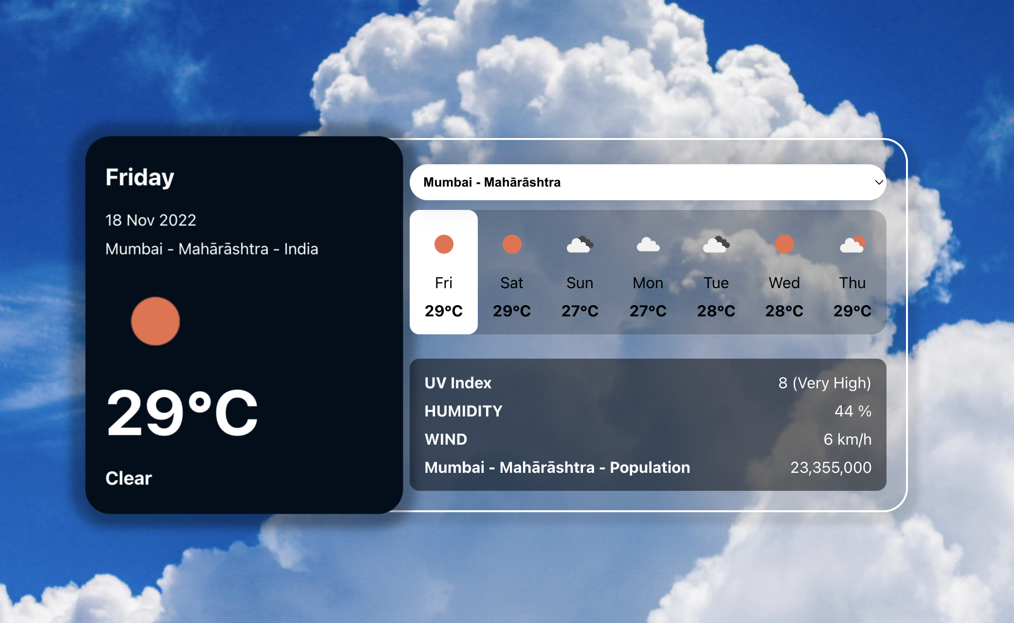

**Postman**

**Submission**

1. Create the ZIP file having all your source code**.** Remove **node_modules** folder before zip.
2. Put the screenshots of all your outputs.
3. Put the screenshots of POST man response.
4. Upload the ZIP file having name **studentId_comp3123_labtest2** and **GitHub project link** on the blackboard on or before the deadline. *NO email will be accepted for any late submission of GitHub/screenshots links and source code.*
5. **ZERO** % will be awarded for any late submission.

**Communication**

Please contact on [pritesh.patel2@georgebrown.ca](mailto:pritesh.patel2@georgebrown.ca) or SLACK channel for any question or query.

**References**

<https://www.digitalocean.com/community/tutorials/react-axios-react>

<https://openweathermap.org/forecast16>

<https://designrevision.com/react-axios/>

<https://www.smashingmagazine.com/2020/06/rest-api-react-fetch-axios/>